|  |  |
| --- | --- |
| C:\Users\e0294398\Pictures\EGC Upward & Onward Logo.jpg | Eastern Goldfields College  Year 11 Mathematics Methods Investigation 3 |

Name:_________________ **Total marks: 50** **Time: 60 minutes**

**Investigating Interesting Sequences**

**Question 1 (16 marks)**

An irrational number like  that has an infinite number of decimal places can be drawn with some precision.

For a sequence defined recursively as  with  many of the terms are irrational numbers that have an infinite number of decimal places.

(a) Determine the first five terms of the sequence, expressing any irrational numbers in surd form. (4)

(b) To illustrate accurately on a diagram, a right isosceles triangle where the congruent sides are equal to one unit, can be drawn as shown in the diagram below.

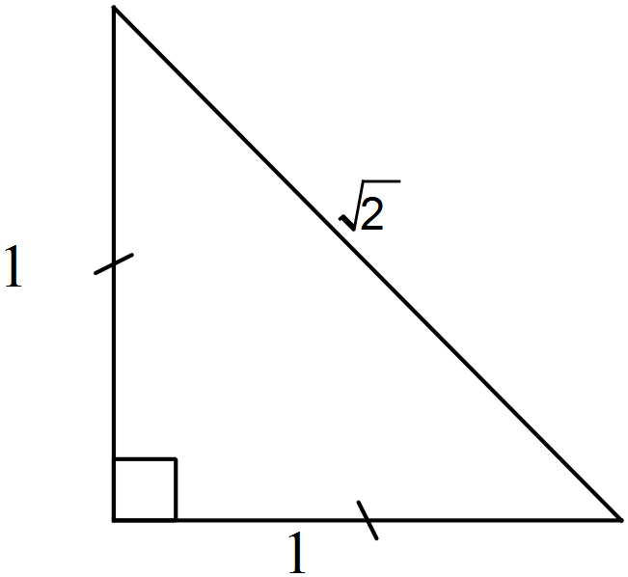

Explain why the length of the hypotenuse is $\sqrt{2}$ units in length. (2)

(c) Determine the length of the line PX. (2)

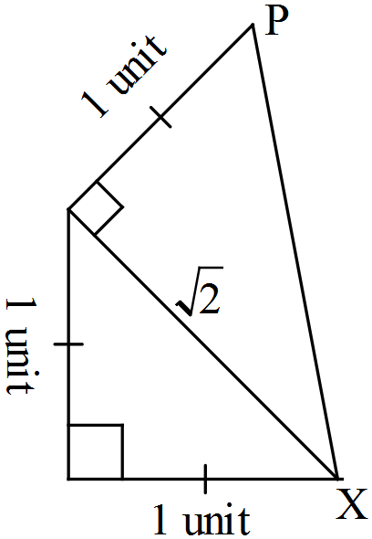

(d) Continue the pattern of completing triangles to illustrate on the diagram drawn above. Explain the process required. (4)

(e) How many triangles will have been drawn in this manner before the final hypotenuse is 64 units in length? Justify your answer. (4)

**Question 2 (20 marks)**

(a) Evaluate the following terms of this sequence, expressing your answers as mixed numerals. (5)

(i) 

(ii) 

(iii) 

(b) The next term in the sequence from part (a) is  . (4)

(i) Write an expression similar to those given above that could be used to determine this value.

(ii) Given that  is the second term of the sequence, state a recursive definition for this sequence.

(c) In decimal form the next three terms are:

1.625, 1.6154, 1.6190, 1.6176, 1.6182, 1.6180, 1.6181, 1.6180

Describe what appears to be happening to successive terms and explain why this is occurring. (3)

(d) The infinite sequence can be described as “One plus, one divided by, one plus, one divided by ….” and may be written as



The equation can be solved by substituting into the equation and obtaining  which simplifies to .

Solve the equation, giving your answers as two surds, α and β, where α > β. (3)

The roots, α and β, have unusual properties.

(e) (i) Show, using operations with surds that: β = 1 – α (2)

(ii) Hence, show that 1 – α = – (3)

**Question 3 (14 marks)**

Listed below are the first twelve terms of the Fibonacci sequence:

1, 1, 2, 3, 5, 8, 13, 21, 34, 55, 89, 144

Using subscript notation we can rewrite this sequence as:

 etc

* 1. Investigate the following pattern. Complete as many rows as necessary to determine a link between each result and a pair of terms in the Fibonacci sequence. At least four results should be calculated.

(4)

|  |  |
| --- | --- |
| Sum of squares of successive terms in the Fibonacci sequence | Result |
|  | 1 |
|  |  |
|  |  |
|  |  |
|  |  |
|  |  |

* 1. WITHOUT calculating a numerical answer, determine an expression for:
     1. 

(2)

* + 1. , where n is any positive integer.

(2)

Investigate this further pattern involving the squares of terms of the Fibonacci sequence. Again, at least four results should be calculated.

(4)

|  |  |
| --- | --- |
| Sum of squares of consecutive pairs of terms in the Fibonacci sequence | Result |
|  | 2 |
|  |  |
|  |  |
|  |  |
|  |  |
|  |  |

* 1. Determine an expression for 

(2)